CO2 Sensor
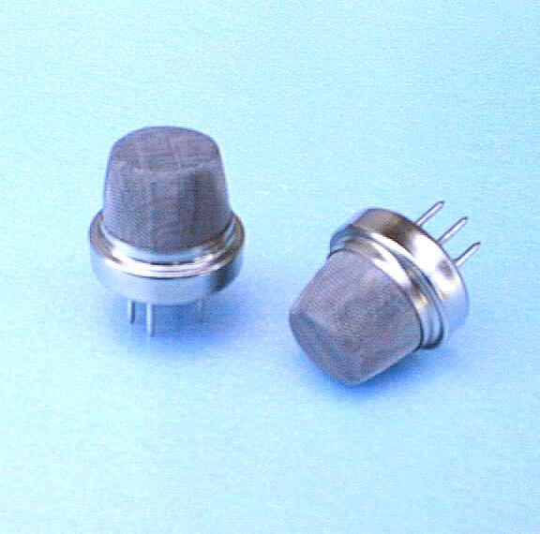
FEATURES
- ▪ High sensitivity to carbon dioxide ▪ Gas diffusion sampling
- ▪ Standard sensor size ▪ Temperature compensated detector elements
- ▪ Fast Response ▪ Wide operating temperature range
- ▪ Internal temperature signal ▪ Low power

DESCRIPTION
Dynament infrared sensors operate by using the NDIR principle to monitor the presence of target gas. The sensor contains a long life tungsten filament infrared light source, an optical cavity into which gas diffuses, a dual temperature compensated pyroelectric infrared detector and an integral thermistor to monitor the internal temperature.

The infrared source should be driven externally with a constant voltage supply switched at a fixed frequency with a 50% duty cycle.The dual pyroelectric detector produces two output signals in response to pulsed incident radiation from the source:• An active signal which decreases in the presence of target gas • A reference signal which is used to monitor the intensity of the source Both signals are composed of a DC offset voltage (typically 0.7V – 1.0V) with a small superimposed response signal alternating in sympathy with the source drive voltage.

The alternating signal must be extracted and amplified in order to obtain a measure of the peak to peak value for both the active and reference. The ratio of active to reference peak to eak
signals is essentially independent of variations in source intensity over time and this ratio reduces in the presence of target gas. The internal temperature signal is used to measure the temperature inside the sensor. The internal temperature is typically 10°C higher than ambient at 20°C due to the heat generated from the infrared source.

This internal heating beneficially reduces the probability of water condensing within the optical cavity.Further details on the sensor, interfacing circuitry and signal extraction can be found in the Dynament application notes,on the Dynament website or by contacting Dynament directly.

MECHANICAL DETAIL SPECIFICATION
- Maximum Power Requirements: 5V d.c. 60mA max. (50% duty cycle source drive)
- Minimum operating voltage: 3.0V d.c. (50% duty cycle source drive)
- Source drive frequency : 2.0Hz minimum, 3.0 Hz typical, 4.0 Hz maximum
- Active mV pk-pk output in N2: 5.2mV typical @ 3Hz, 50% duty cycle
- Reference mV pk-pk output in N2: 4.0mV typical @ 3Hz, 50% duty cycle
- Sensitivity (reduction in active signal) at 20°C, 3Hz, 50% duty cycle:
14% typical @ 5000ppm CO2
30% typical @ 2.0% volume CO2
- Measuring range: 0 -1000ppm up to 0 - 5% volume CO2
- Resolution: 1% of measuring range
- Warm up time: To final zero ± 100ppm : <20s @20°C (68°F) ambient
To specification: < 30 minutes @20°C (68°F) ambient
- Response Time T90: <30s @20°C (68°F) ambient
- Zero Repeatability: ± 50ppm @20°C (68°F) ambient
- Span Repeatability: ± 50ppm @20°C (68°F) ambient
- Long term zero drift: ± 50ppm per month @20°C (68°F) ambient
- Operating temperature range: -20°C to +50°C (-4°F to 122°F)
- Storage temperature range: -20°C to +50°C (-4°F to 122°F)
- Humidity range: 0 to 95% RH non-condensing.
- MTBF: > 5 years
- Temperature signal: Integral thermistor for temperature monitoring
- Weight: 7 grams

